[Applied Learning Task 4]: Embedded Systems - Neil Jiang
Name of the Project: Microbit Multi-Use Watch
Specification Publish Date: 11/11/22
Project Date: 12/08/22
Brief:
In this Applied Learning Task (ALT 4), you will implement a microprocessor system (using the Micro bit) that uses sensors and controls digital and analog inputs and outputs as part of an embedded system.

Evaluation of Ideas: (Brainstorm)
Idea: | Equipment: | Advantages: | Disadvantages:
Weather  Predicter  [REJECTED] | - Pressure Sensor  - Humidity/Moisture Sensor  - Temperature Sensor | - Multiple Outputs | - Multiple External Sensors needed
Traffic Lights  [REJECTED] | - 3 Different colour Leds  - Wires  - Cardboard (Frame) | - Easy to code  - Leds are cheap | - Not enough outputs/inputs  - Already made before  - More of a novelty item
Navigation Device  [REJECTED] | - Compas [built in]  - External battery Pack  - Wires | - No external sensors needed | - Not sure where to progress from there
Mp3/Music Player  [REJECTED] | - Speaker [built in]  - External battery pack | - Can play music that user likes  - Microbit has unique 8-bit type sounds | - Hard to code and store songs onto Microbit  - Needs to automatically convert songs to usable format for Microbit
Fitness Sensor / Multi-Use Watch  [ACCEPTED] | - Two Microbit’s  - Speaker [built in]  - External battery pack  - Cardboard (Watch strap) | - Multi-Use means I can add lots of elements and inputs  - Lots of outputs available  - Can be used by people of all ages | - Price of two Microbit’s are expensive  - Have been done many times  - Hard to program
[Weather Predictor] This is a device that could predict or approximate the weather without any external websites or sources. The Microbit would use local tools attached such as a Pressure Sensor, Temperature Sensor, and a Humidity/Moisture sensor. The pressure sensor was used to determine if a cloud would be approaching, the humidity/moisture sensor would be used to detect if rainfall would be coming, and the temperature sensor would detect the temperature. I quickly scrapped this idea as it would be far to complicated to accurately tell the weather, this is because there are far too much variables and other factors needed to even slightly tell what the weather would be the next day. The sensors needed were also rare and was often out of my budget.
[Traffic Lights] At first I believed that this device would be one of the easiest device to make and program, however this was the downfall. Firstly I needed the device to have multiple inputs and outputs, however as a traffic light the best I could do was to change the led’s from one to another based on time. This lead to only having one input and output, the opposite of what I wanted. Secondly I don’t find the need for a small scale light show as this would be more of a novelty item as apposed to a useful gadget/device.
[Navigation Device] For this idea I wanted to create a device that could track and help people find there way around woods. I wanted to include a compass and a simple GPS to guide the traveler if they are lost, or need to get from point A to point B. I would also include a solar energy battery in case the traveler was in a place where electricity was not present. However I was not sure how to make this gadget with the capabilities the Microbit has, so the idea was dismissed.
[MP3/Music Player] The MP3/Music player was a device that could play songs which the user picked through the built in Microbit speakers. This was because the speakers reminded me of old 8bit gameboy type background music. This device would convert the song into a usable format for the Microbit to play. I thought this would be perfect as it would be a unique experience for each person because they could select their own music. The Microbit would also show a visualization of the sounds and tones it would play. However I never found the solution to convert the raw format of the song to a usable one for the Microbit, but I might revisit this idea in the future as it seems like a fun project to do.
[Fitness Sensor/Multi-use Watch] My final idea and magnum opus was the Fitness Sensor/Multi-use Watch. At first I wanted to make a sports watch such as the Fit bit. It would be able to do the basics such as counting your steps and heart rate whilst also have other functions such as showing the weather and tracking your sleep. But with the limited capabilities of the Microbit I decided to get rid of the weather forecast in replacement of a temperature and light sensor (for reason check previous idea). I also got rid of the sleep tracker altogether for a stopwatch. This was because a sleep tracker is essentially just an automatic timer with the only caveat being that mine is manually started. I also decided to get rid of the heart rate sensor as it was over 20 euro which was over my budget with additional costs for shipping.
Design Process:
DESIGN PROCESS STAGES | Timeline
Investigative | 11/11/22 - 11/11/22
Plan | 14/11/22 - 14/11/22
Design | 15/11/22 - 15/11/22
Create | 15/11/22 - 28/10/22
Evaluate | 29/11/22 - 07/12/22

Code: *(Links only available on online version)
Mainboard Watch:
Version | Updates | Problems | Changes
Mainboard-Watch V1 | - Added stopwatch and step count. | - Leds flashing too slow  - Timing of stopwatch inaccurate | N/A
Mainboard-Watch V2 | - Added pause when showing value for stopwatch and step count. | {MINOR PROBLEM}  - More inputs needed | - Changed Led Display for stopwatch  - Better scrolling Text
Mainboard-Watch V3 | - Added early prototype of sound feedback. | {MAJOR PROBLEM}  Stopwatch Functionality still broken | - Changed Led Display for stopwatch 2nd time
Mainboard-Watch V4 | - Added sound feedback for all inputs and also implemented a startup song. | {MINOR PROBLEM}  - More inputs needed | - Changed Led Display for stopwatch 3rd time  - Stopwatch fixed with redesigned code
Mainboard-Watch V5 | - Improvements made to feedback inputs and more  - Added light sensor and temperature sensor | - Need to make light sensor and temperature show faster | - Changed Led Display for stopwatch, final time  - Stopwatch more accurate
Mainboard-Watch V6  [FINAL VERSION] | -Temperature and light sensor scrolling text timings | N/A | N/A

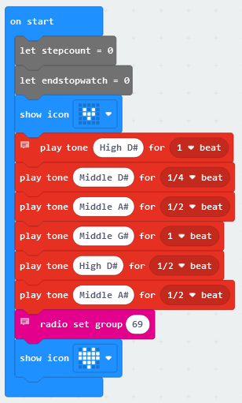
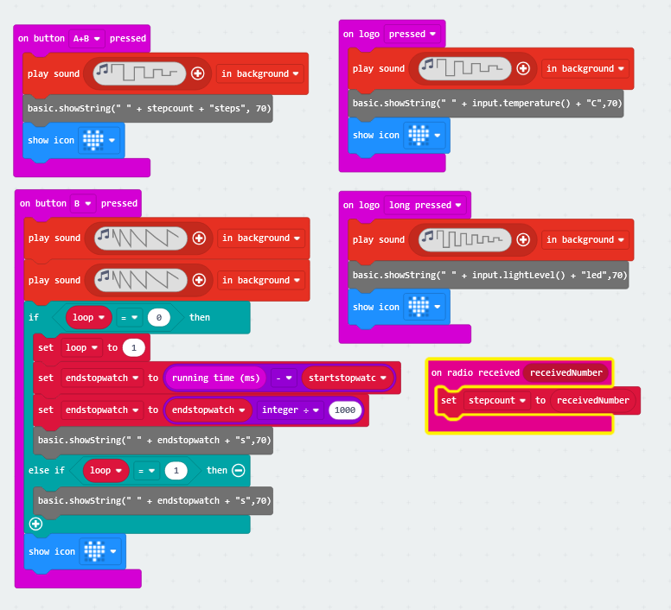

This piece of code designates what each button press will do:
Button B will Stop and show the stopwatch.
In this piece of code, It sets the radio group Button A+B will show the step count
to 69. This will be used to communicate with Short Press on Logo will show the Temperature
the ankle sensor. This code also contains a Long Press on Logo will show Light Level
startup “jingle/song” that plays to tell you
that it has started.

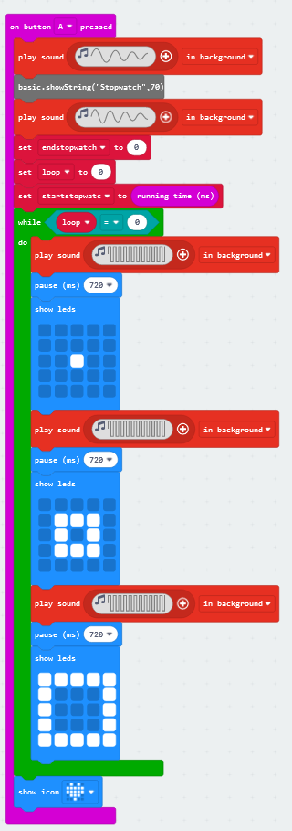
This is the Stopwatch and is activated by button A This piece of code was the hardest to make and design by far. I kept on running into problems as it would always be inaccurate, or it would continue
to count even if you “stop it”.

Ankle Sensor
Version | Updates | Problems | Changes
Ankle-Step-Count V1 | - Simple radio connection to Mainboard to send steps | - Tolerance for steps are bad | N/A
Ankle-Step-Count V2 | - Added Led lights when detecting lights | - Tolerance for steps better but still too unusable | - Change for steps from shake to 6g
Ankle-Step-Count V3  [FINAL VERSION] | - Secret snake game when button A and button B pressed simultaneously | N/A | - Change for steps from 6g to 4g

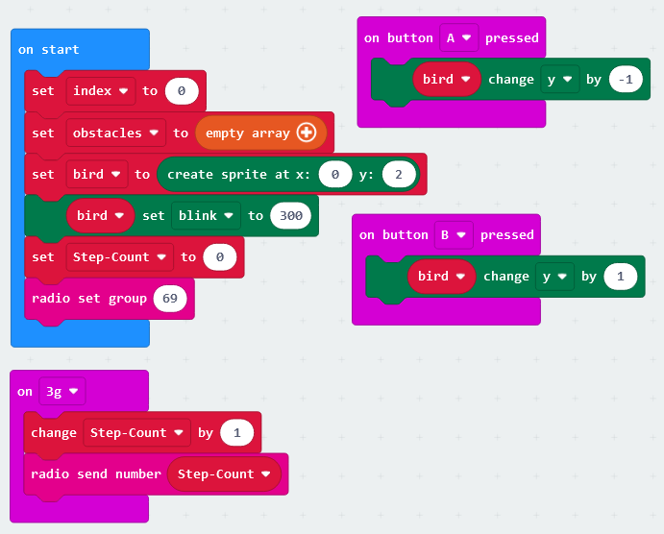

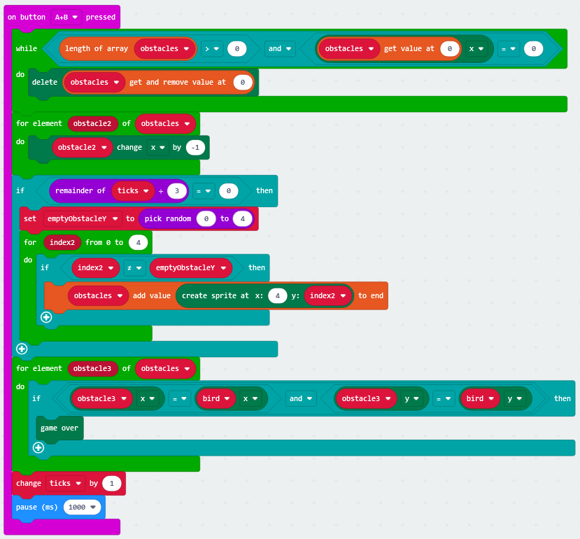

Reflection:
During this project I have learned many new skills. I learned how to debug and troubleshoot nasty bugs and to brainstorm to think of new ideas. I learned that coding one line multiple times in different ways was a very useful way to optimize the code for efficiency and debug bugs and problems.
I do believe that I can further improve the code and project in many ways, first of all I would try to include a watch where you could set the time and know what time it is. Secondly I would also try include the heartrate monitor if the prices were more cheaper.
If I could redo the entire project then, I would find another faster and better solution to solve the stopwatch section as it took by far the most time and effort to create, yet I still am unhappy with it. I would also add like to find another way to display the temperature and light sensor outputs.
Overall I am happy with this project and it taught me many valuable lessons.

